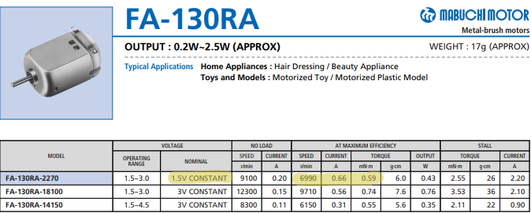

Source: <https://www.pololu.com/file/download/fa_130ra.pdf?file_id=0J11>

Possible Gearbox ratios: 203:1 or 58:1 (<https://core-electronics.com.au/tamiya-70097-twin-motor-gearbox-kit.html>)

Angular Velocity Calculation:

$$Output RPM=\frac{Input RPM}{Gear Ratio}$$

$$Output {RPM}_{GR:58}=\frac{6990}{58}$$

$$Output {RPM}_{GR:58}≈120RPM$$

$$Output {RPM}_{GR:203}=\frac{6990}{203}$$

$$Output {RPM}_{GR:203}≈34RPM$$

Linear Velocity Calculation:

$$v=C ω$$

$$v_{GR:58}=50π×120$$

$$v_{GR:58}=18930.804mm/min$$

$$v_{GR:58}≈0.32m/s$$

$$v_{GR:203}=50π×34$$

$$v_{GR:203}=5339.160mm/min$$

$$v_{GR:203}≈0.089m/s$$

Calculation of time taken to cover test area:

$$Test Area Diameter=1.65m$$

$$Area=Vehicle Width×Travel Distance$$

$$∴Distance=\frac{Area}{Vehicle Width}$$

$$Distance=\frac{π{(\frac{1.65}{2})}^{2}}{130×{10}^{-3}}$$

$$Distance≈16.44m$$

$$Speed=\frac{Distance}{Time}$$

$$Time=\frac{Distance}{Speed}$$

$${Time}_{GR:58}=\frac{16.4m}{0.32m/s}$$

$$≈52 seconds$$

$${Time}_{GR:203}=\frac{16.4m}{0.089m/s}$$

$$≈184 seconds$$

$$≈3 minutes$$

Torque Calculations:

$$τ_{out}=Motor torque×GR$$

$$τ_{outGR:58}=0.59×58$$

$$=34.22mN∙m$$

$$τ_{outGR:58}=0.59×58$$

$$τ_{outGR:203}=0.59×203$$

$$=119.77mN∙m$$

Summary Table:

|  |  |  |
| --- | --- | --- |
| Criteria | 58:1 Gear Ratio | 203:1 Gear ratio |
| Speed $({ms}^{-1})$ | 0.32 | 0.089 |
| Torque $( mN∙m$) | 34 | 120 |
| Time (mins) | 0:52 | 3:04 |

Although the 203:1 gear ratio provides substantially more torque for overcoming rough terrain or inclines, it may not complete the course in the allocated 5 minutes, accounting for stops and re-runs. Hence, the 58:1 gear ratio will be chosen as it provides the required speed.